TASK2: Data Retrieval & Sorting Dashboard
AIM: To develop a web-based dashboard that allows users to store, retrieve, and display
student data efficiently from a database, and present it in a structured format for easy access
and management.
ALGORITHM:
1. Start the application
2. Initialize the server using Express framework
3. Establish database connection using MySQL
4. Load frontend pages (HTML, CSS, JS) in browser
➤ Data Insertion Process:
5. User enters student details (Name, Email, DOB, Department, Phone)
6. Send data to backend using POST request (/addStudent)
7. Execute SQL query to insert data into database
8. Display success message after insertion
➤ Data Retrieval Process:
9. Send GET request to server (/students)
10. Fetch all student records from database
11. Convert data into JSON format
12. Display data dynamically in dashboard table.
13. Arrange data in structured format (table/grid)
14. Allow better readability and management
15.stop.
PROGRAM:
INDEX.HTML:
<!DOCTYPE html>
<html>
<head>
<title>Student Portal</title>
<link rel="stylesheet" href="style.css">
</head>
<body>
<div class="home-container">
<h1>Welcome to Student Portal</h1>
<p>Register and manage student information easily.</p>
<a href="registration.html" class="start-btn">Go to Registration</a>
<a href="dashboard.html" class="start-btn">View Dashboard</a>
</div>
</body>
</html>
REGISTRATION.HTML:
<!DOCTYPE html>
<html>
<head>
<title>Student Registration</title>
<link rel="stylesheet" href="style.css">
</head>
<body>
<div class="container">
<h1>Student Registration</h1>
<button onclick="goHome()" class="home-btn">Home</button>
<form id=”studentForm”>
<label>Name</label>
<input type="text" id="name" placeholder="Enter your name" required>
<label>Email</label>
<input type="email" id="email" placeholder="Enter your email" required>
<label>Date of Birth</label>
<input type="date" id="dob" required>
<label>Department</label>
<select id="department" required>
<option value="">Select Department</option>
<option>CSE</option>
<option>IT</option>
<option>ECE</option>
<option>MECH</option>
</select>
<label>Phone</label>
<input type="text" id="phone" placeholder="Enter phone number" required>
<button type="submit">Register</button>
</form>
</div>
<script src="script.js"></script>
</body>
</html>
DASHBOARD.HTML:
<!DOCTYPE html>
<html>
<head>
<title>Student Dashboard</title>
<link rel="stylesheet" href="dashboard.css">
</head>
<body>
<div class="container">
<button onclick="goHome()" class="home-btn">Home</button>
<h1>Student Dashboard</h1>
<div class="controls">
<select id="sortSelect">
<option value="">Sort By</option>
<option value="name">Name</option>
<option value="dob">Date of Birth</option>
</select>
<select id="departmentFilter">
<option value="">Filter by Department</option>
<option value="CSE">CSE</option>
<option value="IT">IT</option>
<option value="ECE">ECE</option>
<option value="MECH">MECH</option>
</select>
<button onclick="loadStudents()">Apply</button>
</div>
<table>
<thread>
<tr>
<th>ID</th>
<th>Name</th>
<th>Email</th>
<th>DOB</th>
<th>Department</th>
<th>Phone</th>
</tr>
</thead>
<tbody id="studentTable"></tbody>
</table>
<h2>Department Count</h2>
<div id="deptCount"></div>
</div>
<script src="dashboard.js"></script>
<script>
function goHome(){
window.location.href = "index.html"
}
</script>
</body>
</html>
STYLE.CSS:
body{
font-family: 'Segoe UI', sans-serif;
background: linear-gradient(135deg,#0f2027,#203a43,#2c5364); height:100vh;
display:flex;
justify-content:center;
align-items:center;
margin:0;
}
.container{
width:420px;
padding:35px;
background:rgba(255,255,255,0.08);
border-radius:18px;
backdrop-filter: blur(10px);
box-shadow:0 10px 35px rgba(0,0,0,0.6);
}
h1{
text-align:center;
color:white;
margin-bottom:25px;
}
h2{
text-align:center;
color:white;
margin-top:30px;
}
form{
display:flex;
flex-direction:column;
}
label{
color:#ddd;
font-size:14px;
margin-bottom:5px;
margin-top:10px;
}
input,select{
width:100%;
padding:12px;
border:none;
border-radius:8px;
background:#27496d;
color:white;
font-size:14px;
outline:none;
margin-bottom:5px;
}
input:focus,select:focus{
box-shadow:0 0 8px #00eaff;
background:#2c5d8a;
}
button{
margin-top:15px;
padding:12px;
border:none;
border-radius:10px;
background:linear-gradient(45deg,#ff4b2b,#ff416c);
color:white;
font-size:16px;
font-weight:bold;
cursor:pointer;
transition:0.3s;
}
button:hover{
transform:scale(1.05);
box-shadow:0 0 15px #ff416c;
}
#studentList{
margin-top:15px;
text-align:center;
color:white;
font-size:15px;
}
.home-container{
text-align:center;
color:white;
background:rgba(255,255,255,0.08);
padding:50px;
border-radius:20px;
backdrop-filter: blur(10px);
box-shadow:0 10px 35px rgba(0,0,0,0.6);
width:420px;
}
.home-container h1{
font-size:32px;
margin-bottom:15px;
}
.home-container p{
margin-bottom:30px;
color:#ddd;
}
.start-btn{
text-decoration:none; padding:12px 25px;
border-radius:10px;
background:linear-gradient(45deg,#ff4b2b,#ff416c);
color:white;
font-weight:bold;
transition:0.3s;
}
.start-btn:hover{
transform:scale(1.05);
box-shadow:0 0 15px #ff416c;
}
DASHBOARD.CSS:
body{
font-family:Segoe UI;
background:linear-gradient(135deg,#0f2027,#203a43,#2c5364);
margin:0;
padding:0;
display:flex;
justify-content:center;
}
.container{
width:900px;
margin-top:40px; background:rgba(255,255,255,0.08);
padding:30px;
border-radius:15px;
backdrop-filter:blur(10px);
color:white;
}
h1{
text-align:center;
margin-bottom:20px;
}
.controls{
display:flex;
gap:10px;
margin-bottom:20px;
}
select,button{
padding:10px;
border:none;
border-radius:6px;
}
button{
background:#ff416c; color:white;
cursor:pointer;
}
table{
width:100%;
border-collapse:collapse;
background:rgba(255,255,255,0.1);
}
th,td{
padding:10px;
text-align:center;
}
th{
background:#1f4068;
}
tr:nth-child(even){
background:rgba(255,255,255,0.05);
}
#deptCount{
margin-top:15px;
font-size:16px;
}
color:white;
cursor:pointer;
}
table{
width:100%;
border-collapse:collapse;
background:rgba(255,255,255,0.1);
}
th,td{
padding:10px;
text-align:center;
}
th{
background:#1f4068;
}
tr:nth-child(even){
background:rgba(255,255,255,0.05);
}
#deptCount{
margin-top:15px;
font-size:16px;
method:”POST”,
headers:{
“Content-Type":"application/json"
},
body:JSON.stringify(student)
})
const data = await res.text()
alert(data)
// clear form
form.reset()
}catch(error){
console.log("Error:",error)
}
})
function goHome(){
window.location.href="index.html"
}
SERVER.JS:
const express = require("express")
const cors = require("cors")
const path = require("path")
const db = require("./db")
const app = express()
app.use(cors())
app.use(express.json())
// Serve static files (HTML, CSS, JS)
app.use(express.static(__dirname))
// Redirect root link to index.html
app.get("/", (req, res) => {
res.sendFile(path.join(__dirname, "index.html"))
})
// Insert student data
app.post("/addStudent", (req, res) => {
const {name,email,dob,department,phone} = req.body
const sql = "INSERT INTO students(name,email,dob,department,phone) VALUES (?,?,?,?,?)"
db.query(sql,[name,email,dob,department,phone],(err,result)=>{
if(err){
res.send(err)
}else{
res.send("Student Added Successfully")
}
})
})
// Get student data
app.get("/students",(req,res)=>{
db.query("SELECT * FROM students",(err,result)=>{
if(err){
res.send(err)
}else{
res.json(result)
}
}}
}}
app.listen(3000,()=>{
console.log("Server running at: http://localhost:3000")
})
DB.JS:
const mysql = require("mysql")
const db = mysql.createConnection({
host: "localhost",
user: "root",
password: "fahi",
database: "studentdb"
})
db.connect((err)=>{
if(err){
console.log("Database Error:", err)
}else{
console.log("MySQL Connected Successfully")
}
}}
Module.exports=db
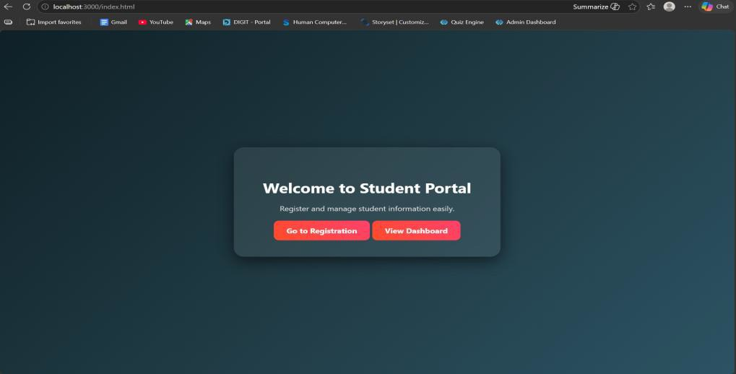
RESULT: The system successfully stores, retrieves, and displays student data efficiently through a user-friendly dashboard.

